**Requirement Gathering and Analysis Phase**

**Technology Stack (Architecture & Stack)**

|  |  |
| --- | --- |
| Date | 5 July 2024 |
| Team ID | SWTID1720019378 |
| Project Name | Project - HouseHunt |
| Maximum Marks |  |

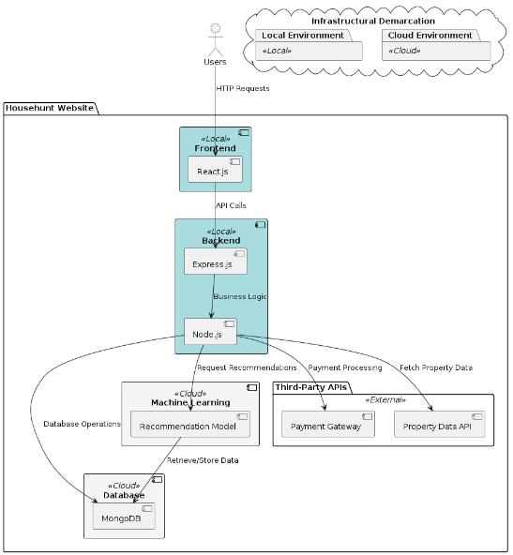

**Technical Architecture:**

**Table-1 : Components & Technologies:**

|  |  |  |  |
| --- | --- | --- | --- |
| **S.No** | **Component** | **Description** | **Technology** |
|  | Search and Filters | Search for properties by location, price range, and property type. | React, Node.js, Express, MongoDB |
|  | User Accounts & Communication | Create an account with Gmail authentication and save searches. | React, Node.js, Express, MongoDB, OAuth |
|  | User Accounts & Communication | Receive confirmation email upon registration. | React, Node.js, Express, MongoDB,  Nodemailer |
|  | Market Insights | View an indicator on listings of current and past price changes in the area. | React, Node.js, Express, MongoDB, Chart.js |
|  | Environmental data | See an overlay on listings showing estimated noise levels and air quality. | React, Node.js, Express, MongoDB,  AirVisual API |
|  | Detailed Listings | View detailed listings with high-quality photos and videos. | React, Node.js, Express, MongoDB,  AWS S3 |
|  | User Accounts & Communication | Contact sellers or landlords directly through the platform. | React, Node.js, Express, MongoDB, Socket.io |
|  | Neighbourhood Insights | Gain insights into the surrounding neighbourhood, including schools, parks, and amenities. | React, Node.js, Express, MongoDB, Google Maps API. |
|  | Community Rating, Reviews and Feedback | Read reviews from other users about neighbourhoods and property management companies. | React, Node.js, Express, MongoDB, Yelp API |
|  | School district & commute overlays | Filter listings based on commute time to specific locations (work, school). | React, Node.js, Express, MongoDB, Google Distance Matrix API. |
|  | Dashboard for sellers, agents and landlords | Host a live, interactive open house directly on the platform. | React, Node.js, Express, MongoDB, WebRTC |
|  | Notifications | Receive notifications when new listings matching saved searches become available. | React, Node.js, Express, MongoDB, Firebase Cloud |
|  | Security Considerations Enforcement | Deal only with legitimate and authorized individuals, ensuring property information is secure. | React, Node.js, Express, MongoDB, JWT |

**Table-2: Application Characteristics:**

| **S.No** | **Characteristics** | **Description** | **Technology** |
| --- | --- | --- | --- |
|  | Open-Source Frameworks | List the open-source frameworks used | React, Node.js, Express, MongoDB, OAuth, Chart.js, AirVisual API, AWS S3, Socket.io, Google Maps API, Yelp API, Google Distance Matrix API, WebRTC, Firebase Cloud, JWT |
|  | Security Implementations | List all the security / access controls implemented, use of firewalls etc. | JWT, OAuth, Nodemailer |
|  | Scalable Architecture | Justify the scalability of architecture (3 – tier, Micro-services) | |  | | --- | | React, Node.js, Express, MongoDB |  |  | | --- | |  | |
|  | Availability | Justify the availability of application (e.g. use of load balancers, distributed servers etc.) | |  | | --- | | React, Node.js, Express, MongoDB,  Firebase Cloud |  |  | | --- | |  | |
|  | Performance | Design consideration for the performance of the application (number of requests per sec, use of Cache, use of CDN’s) etc. | React, Node.js, Express, MongoDB, AWS S3 |